Lab Report: Measurement of Friction Coefficients Between a Smartphone Screen and a Wooden Board
I. Objectives
1. Accurately measure static and kinetic friction coefficients between a mobile phone and a smooth wooden surface.
2. Enhance understanding and practical skills in friction-related phenomena and measurement techniques.
3. Analyze how different angles, phone orientations, and additional weight influence frictional behaviour.

II. Experimental Apparatus
1. Smooth wooden plank (~10cm width, 100cm length)
2. Mobile phone (mass: 168.2 g, replacing a glass cup in the original experiment)
3. Stopwatch or smartphone timer
4. Protractor
5. Measuring tape
6. Scale (optional, to measure mass variations)
7. Marker or pencil
III. Theoretical Basis
1. The static friction coefficient (μ_{s}) is found by slowly elevating one side of a wooden plank until the phone starts slipping, noting the critical angle (θ). The static friction coefficient formula is:
$$μ_{s}=\tan{θ }$$
2. For kinetic friction coefficient ($μ_{k}$), the phone is released from rest on the inclined plank, sliding down a known distance (s). Time (t) is measured, acceleration (a) is calculated, and the kinetic friction coefficient is obtained by:
$$μ_{k}=\frac{g\sin{θ-a}}{g\cos{θ}}$$
IV. Procedures
1. Static friction measurement:
(1) Position the phone at the plank's lower end.
(2) Gradually raise the plank until the phone slips.
(3) Record the angle θ and average over multiple trials.
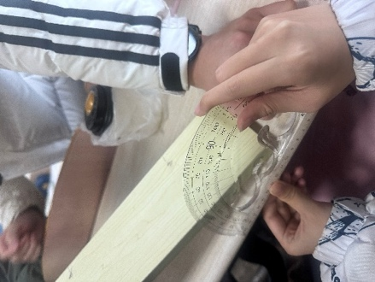
Figure 1. Slowly raise one end of the wooden board Figure 2. Record the tilt angle when the phone starts sliding $θ$
2. Kinetic friction measurement:
(1) Fix the plank at specific angles (e.g. 21°, 13.5°, and 10°).
(2) Measure the time taken for the phone to slide 80cm, calculate the average time, derive acceleration, and subsequently μ_{k}.

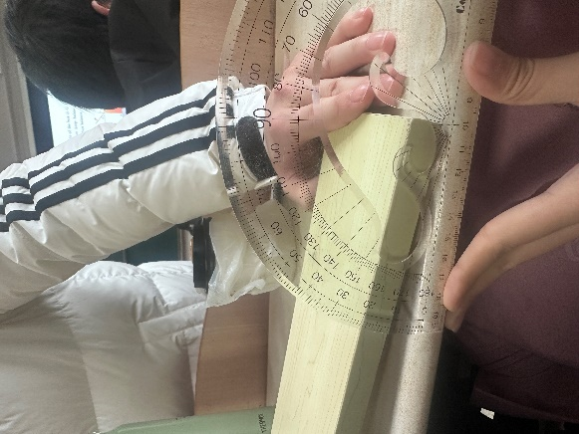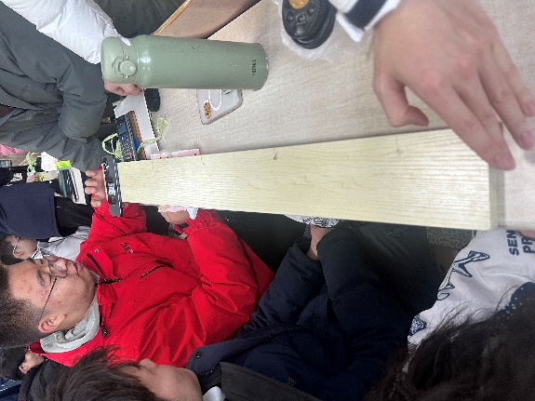
Figure 3. Set the initial tilt angle $θ$ Figure 4. Record time with a stopwatch

3. Additional investigations:
(1) Flip the phone upside-down and repeat tests.
(2) Increase the phone's mass and examine frictional changes.
(3) Measure $μ_{s}$ and ${ μ}_{k}$ with the smartphone inverted (screen down).

V. Experimental Data (Illustrative)
Table 1: Static Friction Coefficients
Tilt angle (three measurements) | 16.5°, 16°, 17°
Average inclination angle $θ$ | 16.5°
$$μ_{s}=\tan{θ }$$ | $$\tan\left(16.5°\right)≈0.296$$

Table 2: Kinetic Friction Coefficients
Sliding Distance | 80cm
Tilt angle | 21° |  |  | 13.5° |  |  | 10°
Sliding time | 0.97s | 1.03s | 1.00s | 1.00s | 1.13s | 1.24s | 1.71s | 1.69s | 1.84s
Average sliding time | 1.00s |  |  | 1.12s |  |  | 1.75s
Acceleration a$\left(m/s^{2}\right)$ | 0.8 |  |  | 0.64 |  |  | 0.26
$${ μ}_{k}$$ | 0.206

Table 3: Additional Experiments
Inverted Phone $μ_{s1}$ | 0.31
Inverted Phone $μ_{k1}$ | 0.28
Loaded Phone $μ_{s2}$ | 0.301
Loaded Phone $μ_{k2}$ | 0.211

VI. Observations and Analysis
1. $μ_{s}=0.296$, ${ μ}_{k}=0.206$, consistent with the theory $μ_{s}>{ μ}_{k}$.
2. Sensitivity in measuring the critical angle was noted, indicating potential measurement errors.
3. Manual timing introduced noticeable human error; precise timing devices are recommended.
4. Ensuring surface cleanliness notably reduced variability in measured values.

VII. Conclusions
1. Static and kinetic friction coefficients were reliably determined (~0.296 and ~0.20, respectively).
2. Orientation and additional weight affected friction values, underscoring the importance of surface interactions.
3. Experiment validated theoretical predictions, enhancing conceptual comprehension.

VIII. Discussion
1. Friction is a double-edged sword in engineering. Its positive applications include braking systems (friction deceleration), belt drives (power transmission), and bolt pre-tightening (anti-loosening). However, uncontrolled friction leads to mechanical wear (e.g., engine pistons), material degradation (train wheel-rail systems), or thermal hazards (spacecraft re-entry). Balancing its effects requires lubrication, material reinforcement, or thermal insulation design.
2. When vehicles brake on elevated bridges, horizontal friction forces generate dynamic loads that impact the bridge deck (causing stress concentration) and transfer to piers (inducing additional bending moments), potentially leading to long-term structural fatigue. Mitigation strategies include shock-absorbing bearings and continuous beam designs to disperse loads, high-durability pavement materials to stabilize friction, and speed limit controls to reduce abrupt braking frequency—ensuring bridge safety from a mechanical perspective.

